Report Week 7

Achievements:
- First functioning version of functioning ID Algorithm:

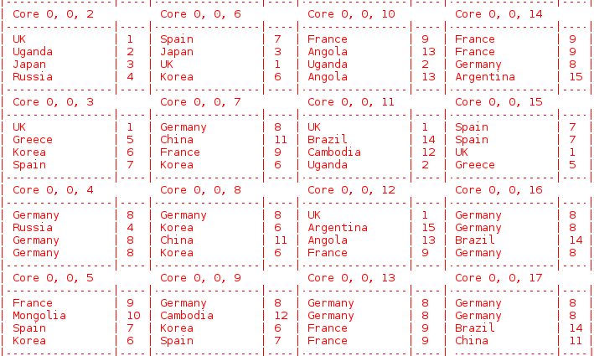
Goals for next week:
- Prepare for the seminar
- Build a more efficient edge network (e.g. a tree structure)

